Profile

1. Name : M.VENKATESWARA RAO 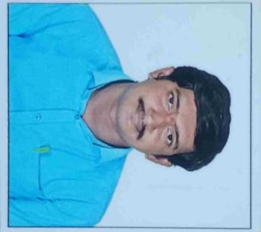
2. Designation : LECTURER IN ECONOMICS
3. Date of Birth :14-05-1992
4. Educational Qualifications :M.A
5. Teaching experience :10 YEARS
6. Research Experience : 0
7. Dissertation/Thesis Title : 0
8. No. of Research publications : 0
9. No. of Books Published : 0
10. No. of Major/Minor Research Projects: 0
11. Title of Minor Research Project : 0
12. No .of International Conferences Attended : 03
13. No. of National Conferences Attended : 14
14. No. of Papers Presented at the Seminars/Conferences: 0
15. Refresher Courses/Orientation Programs/Training Programs Attended: 03
16. Vidwaan Score : 0
17. Address : POLAMURU -543238

PENUMANTRA MANDAL

1. E-mail Id : madsuvenkat225@gmail.com
2. Contact no : 7893363026